# Introduction to CARIN Blue Button

CARIN® which is an acronym for Creating Access to Real-time Information Now through Consumer-Directed Exchange, Blue Button allows consumer-directed exchange of clinical data, claims and encounter data, plan coverage and drug formularies. It also allows for the safe and secure exchange of beneficiaries’ medical information between the various applications and programs that they use to manage their plan. Blue Button uses HL7® FHIR® standards for beneficiary data and OAuth 2.0 standards for identification to ensure that access to and exchange of information is easy and secure.

The CARIN for Blue Button Framework was designed to answer the challenge for health plans to ‘meet or exceed’ the CMS® Blue Button 2.0 capabilities. The goal of the CARIN Alliance Health Plan Workgroup is to develop an agreed upon set of data fields to exchange with consumers and a FHIR-based implementation guide for health plans and consumer facing applications to use to implement the API.

The Centers for Medicare and Medicaid Services (CMS) issued the Interoperability and Patient Access Final Rule on May 1, 2020 as noted on their [*Implementation Guidance*](https://www.cms.gov/Regulations-and-Guidance/Guidance/Interoperability/index) page. Affected stakeholders are Medicare Advantage (MA) plans, state Medicaid and Children’s Health Insurance Program (CHIP) agencies, Medicaid and CHIP managed care plans, and qualified health plan (QHP) issuers in the federally facilitated exchanges (FFEs).

Interoperability Land FHIR PITs offer synthetic data sets that provides developers with the chance to test their applications with accurate data without the risk of using the sensitive Private Health Information of real beneficiaries.

The scenarios and queries in this document illustrate how to retrieve healthcare information covered by the CARIN for Blue Button Framework.

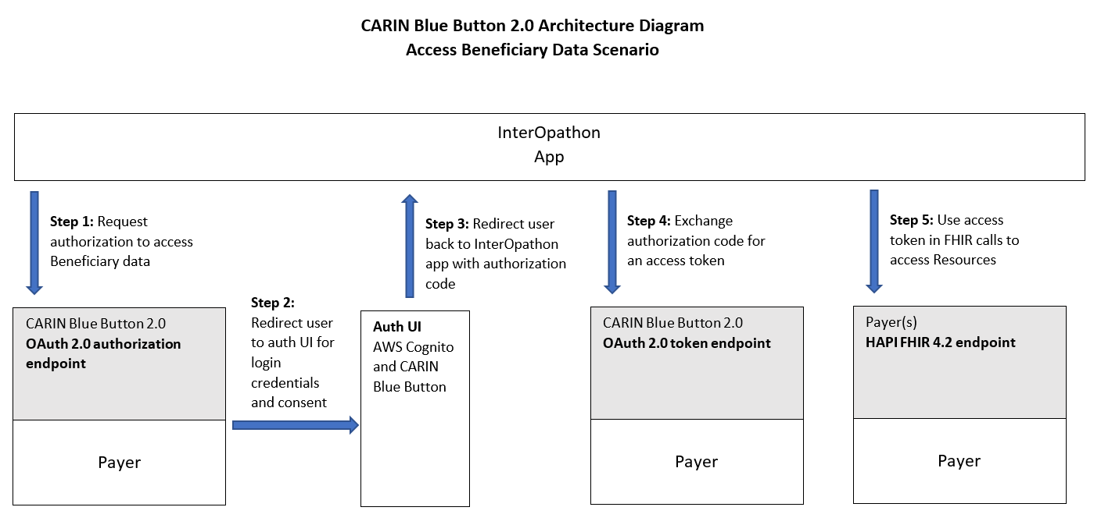

# Document Conventions

## Identifier vs id :

An **identifier** denotes variables whereas an **id** denotes resources.

## Searching in the Raw Message

Information can be found in two ways :

* By scrolling through the results.
* By using **CTRL + F** to use your search box to type in a portion of a keyword relevant to your search.

## Filtering results with the Report Body Bundle

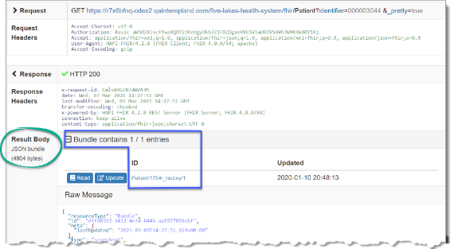The **Result Body** section contains a line at the top that reads **Bundle** contains **1 / 1** entries. This line shows how many results matched the query that was specified.

The first number is the count of results included in this response, the second is the total number of records satisfying that query in this PIT.

When a query matches many records, the numbers can be different because the FHIR server has a limit on the number of records it can return in a single response.

## Search Parameters Add Tool

Click Add ( [](https://us-prod.asyncgw.teams.microsoft.com/v1/objects/0-eus-d13-92fe3deb1ab2c9b690436b7ed8a5fd54/views/imgo)) in Search Parameters when you need to add a search parameter.

Contents

Introduction to CARIN Blue Button 1

Document Conventions 2

Identifier vs id : 2

Searching in the Raw Message 2

Filtering results with the Report Body Bundle 2

Search Parameters Add Tool 3

Scenario 1- Showcasing Explanation of Benefits (EOBs) and Coverage Info from One PIT 1

Problem Statement 1

Problem Solution 1

Stakeholder Participation 1

Query 1 – Finding A Patient by First and Last Name 2

Query 2 – Locating EOB Records for the Patient 6

Query 3 – Finding Coverage information for the Patient 9

Scenario 2: Navigating Co-insurance 10

Problem Statement 10

Problem Solution 10

Stakeholder Participation 10

Query 1 – Finding A Patient By SSN 11

Scenario 3: Comparing Medication Prices 14

Problem Statement 14

Problem Solution 15

Stakeholder Participation 15

Query 1 – Finding the Patient’s id on an EHR PIT (Soldier Healthcare Alliance) 16

Query 2 – Finding Medication Requests for the Patient (Soldier Healthcare Alliance) 18

Query 3 -Finding a Patient’s Coverage in the SilverCare PIT 20

Query 4- Finding a Patient’s Prescriptions in Their EOB Records Using the Coverage id 22

Appendix A: CARIN Blue Button Authentication Process 24

Connecting a SMART on FHIR App 25

Creating a SMART Auth User 30

Connecting from the SMART on FIHR Application 32

Acquiring the Authorization Code 32

Connecting Your PIT to OAuth debugger 33

Logging in as a SMART Auth User 34

Obtaining the Access Token with Authorization Code Using Postman 35

Appendix B: Bulk Querying Patient Data 38

Appendix C: Sample Users 39

Appendix D: Judging Criteria 40

# Scenario 1- Showcasing Explanation of Benefits (EOBs) and Coverage Info from One PIT

## Problem Statement

Joyce Diaz needs to view information on her current medical coverage. She is unable to find her insurance card. She would also like to view a list of her EOBs and access information on how to read them.

## Problem Solution

**Action:** Explore ways to showcase a patient’s medical insurance information, review coverage, and allow them to review their EOBs.

**Precondition:** Be able to use the queries listed below in the Better Health Insurance PIT in Interoperability Land™ (IOL).

**Success Criteria:** Successfully locate a patient’s EOBs and coverage information.

## Stakeholder Participation

Queries you will complete:

1. Find a patient id using the patient’s first (given) and last (family) names.
2. Locate the patient’s EOBs using the ExplanationOfBenefitsResource.
3. Review the patient’s coverage information in the CoverageResource.

#### Query 1 – Finding A Patient by First and Last Name

In this query begin by locating Joyce’s id in the **Better Health Insurance**PIT. This can be accomplished by first navigating to and choosing the **Better Health Insurance** PIT from the Sandbox dashboard.

Because the HAPI FHIR® Interface only supports a limited set of Search Parameters, an initial query is necessary to find your Patient record.

***Note:*** *Click Add (* *) in Search Parameters when you need to add a search parameter.*

1. Using the left sidebar Resources navigation menu, choose the **Patient** option and then choose or add your Search Parameters as follows.

***Note:*** *Make a note of your Patient Resource* ***id*** *as you will need it to create more queries later***.**

1. **family – A portion of the family name of the patient**, verify your search is **Matches**, and then type the patient **family** name e.g., Diaz.
2. **given – A portion of the given name of the patient**, verify your search is **Matches**, and then type the patient **given** name e.g., Joyce.
3. Click **Search** ().

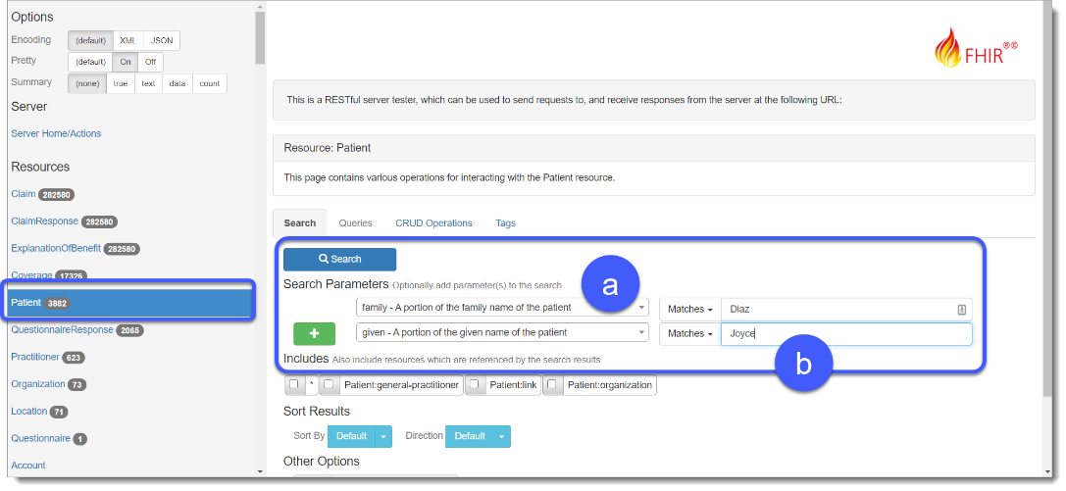

***Tip:*** *To perform a bulk query of patient data, click* ***Search*** *without including the patient* ***identifier*** *in the search parameters.*

The query returns a page with information about the query results and the raw data.

The **Result Body** section displays **Bundle contains 1/1 entries**. The first number is the count of results on the current page, the second is the total number of records returned by the query.

***Note:*** *When a query matches more records than the page limit, the total only displays on the final page of results. The limit defaults to 20 records per page.*

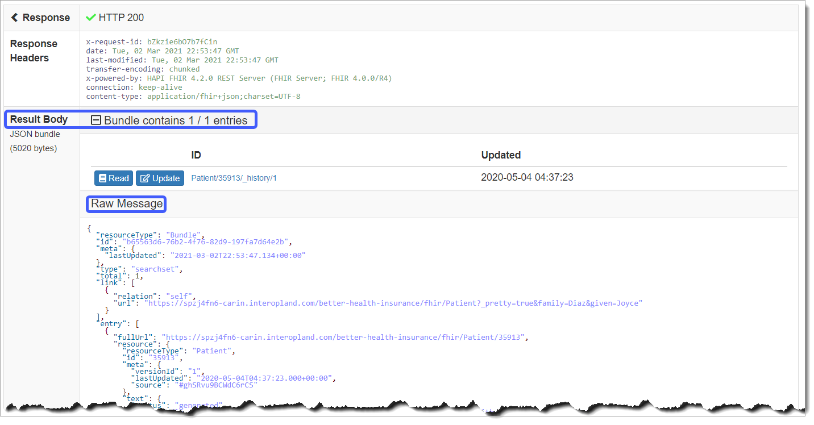

Below the Result Body section is a section labelled **Raw Message**. This section contains the actual data sought by the query (in this case, a Patient record identified by the supplied patient name). If there is more than one message returned for the query this will be a bundle. Choose your Read tool which is next to any Resource listed in the Result Body section to display only that Resource in the Raw Message section of the page.

Nested under the **Resource** element of a member of the **entry** collection, the patient’s **id** is the unique identifier of this patient record within the PIT. Other stakeholder records in this PIT use the **id** to refer to a patient. Use it to search for only those records relevant to a specific patient.

***Note:*** *Make a note of the* patient Resource **id** *as you will need it for the next query.*

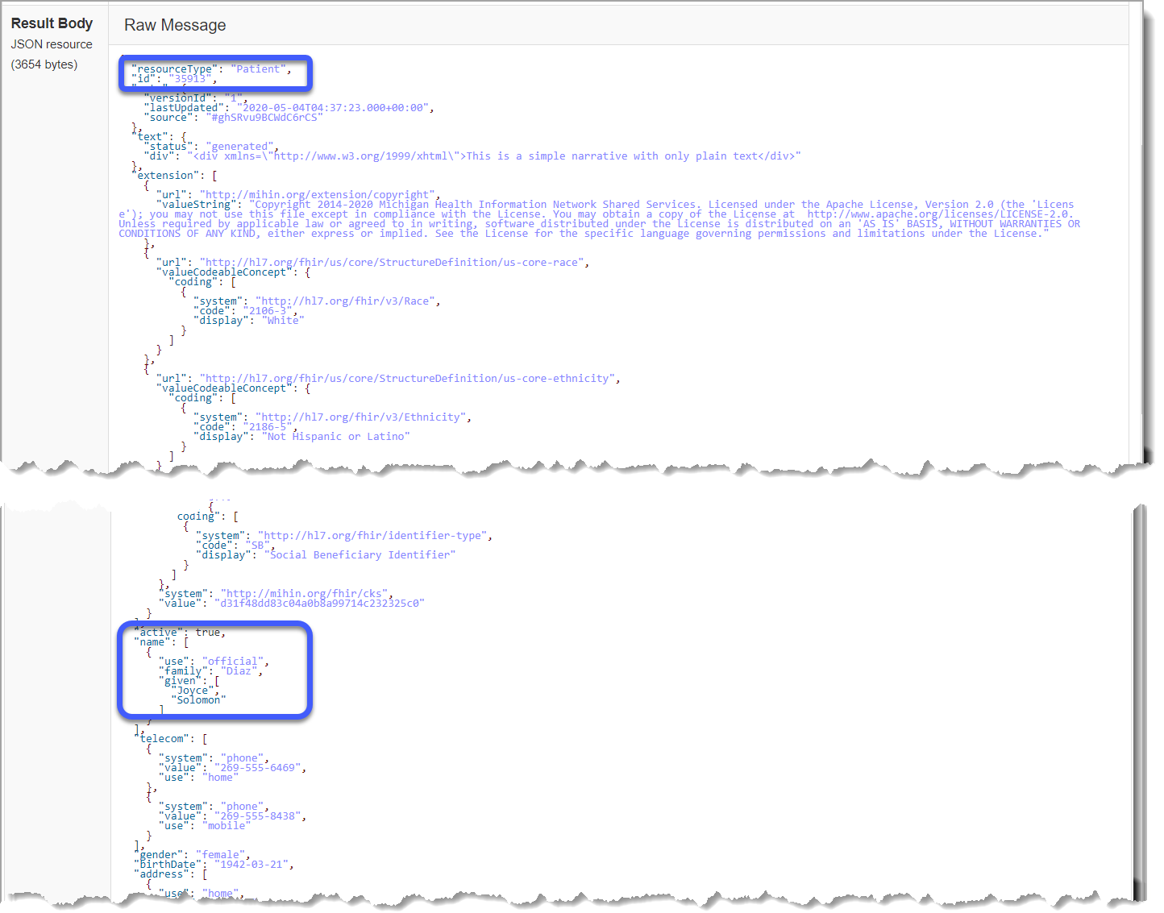

#### Query 2 – Locating EOB Records for the Patient

Once Joyce’s patient Resource id is known, it is possible to locate her explanation of benefits records under the ExplanationOfBenefitResource.

1. Choose the **patient** parameter in the **Search Parameters** dropdown.
2. Type the patient Resource id from the previous query in the Resource id field. See below for an example.
3. Click **Search** ().

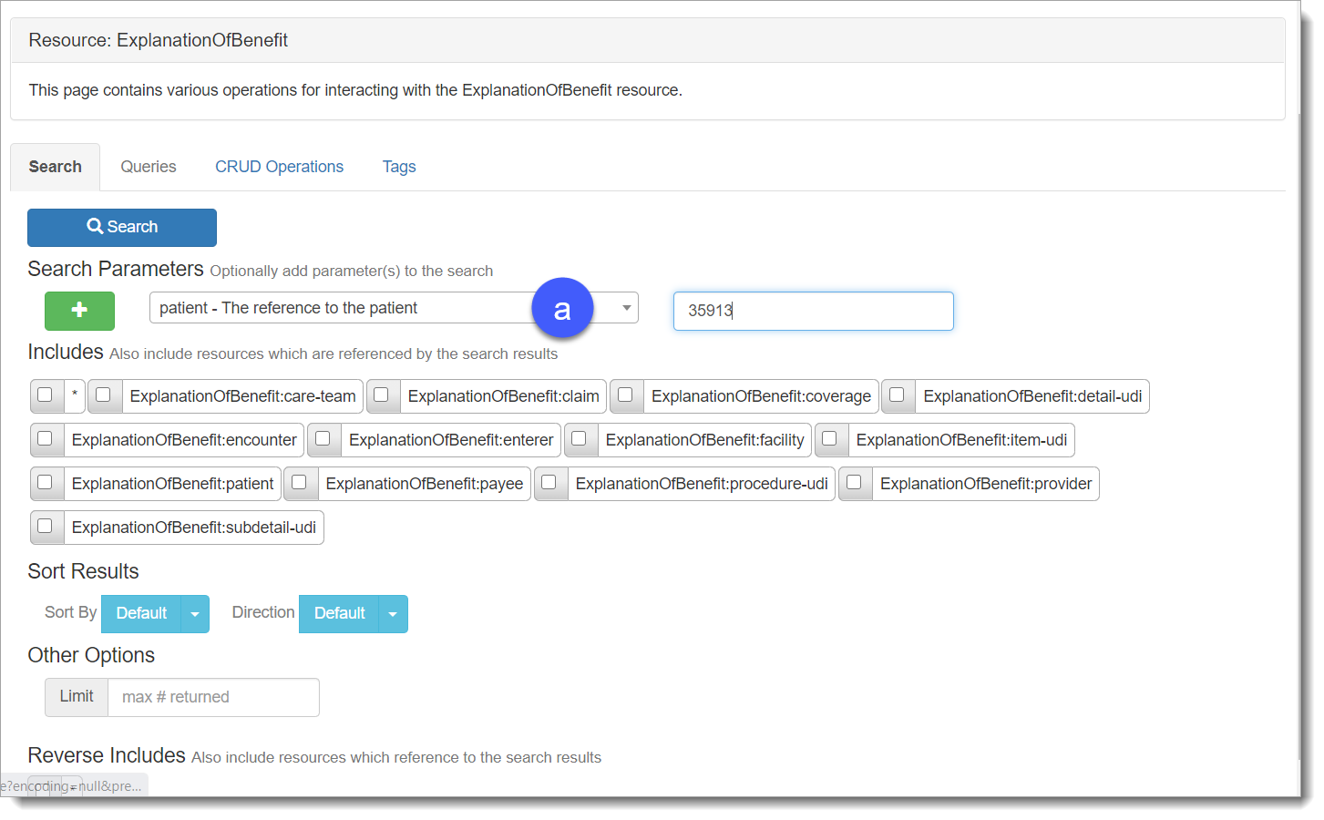

1. This should produce a complete set of EOB records for Joyce in this PIT. There are 221 Resources returned for this query 20 of which will be displayed on the page as a bundle. Select **Read** next to any Resource to view the information for that Resource.

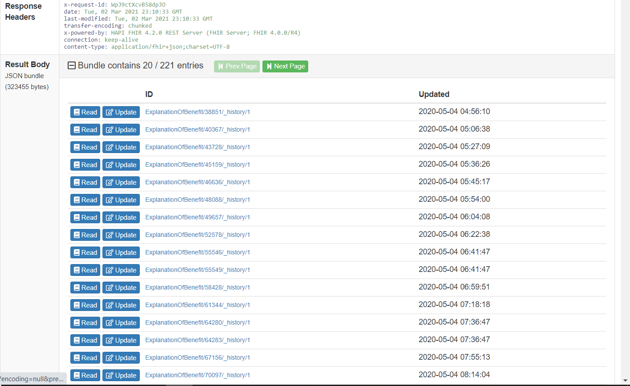

1. Using your Raw Message data you can now find the EOB **id**.

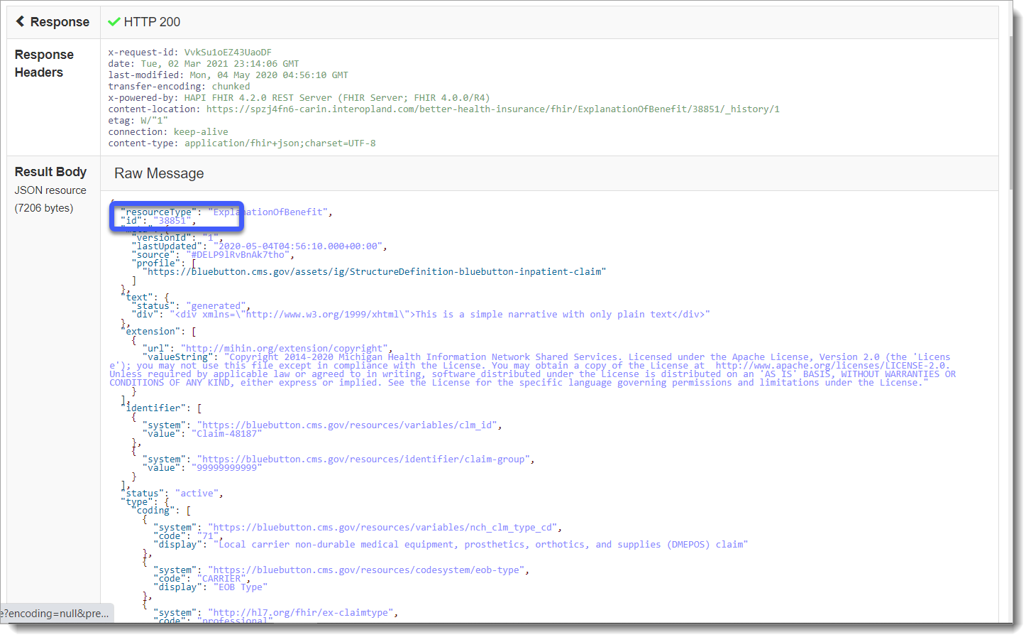

#### Query 3 – Finding Coverage information for the Patient

1. Coverage information for a patient can be found by selecting the **Coverage** Resource from the navigation panel.
2. Using your **Search Parameters** arrow, choose the **patient – Retrieve coverages for a patient** option,and then type the patient Resource **id** that you used above in the corresponding box.
3. Click **Search** ().

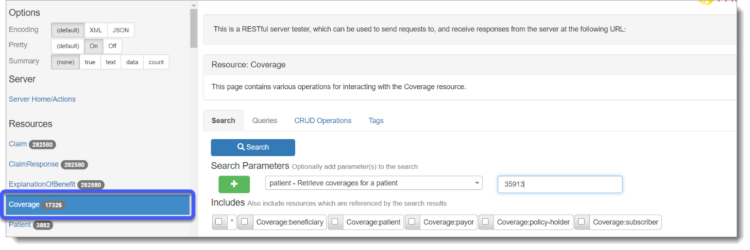

1. 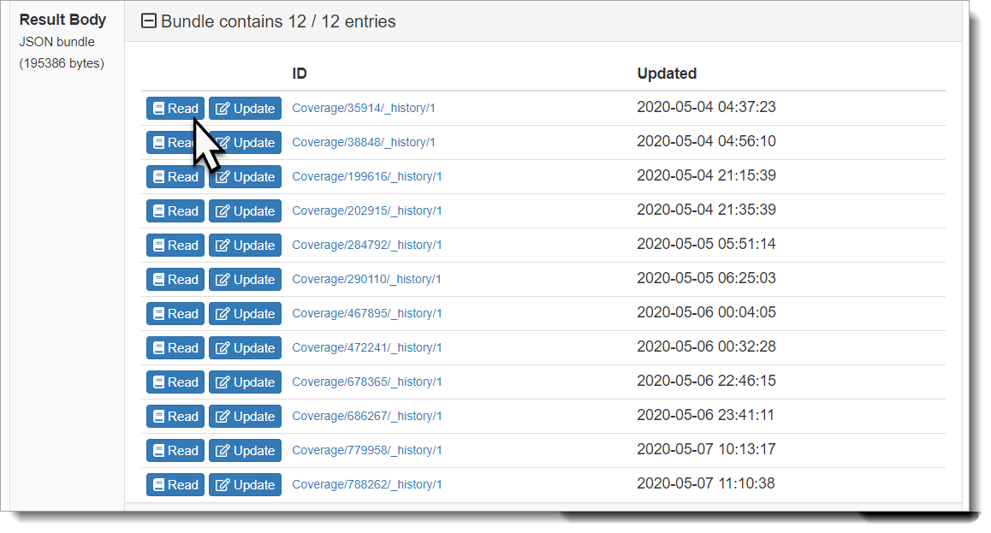The query retrieves Joyce’s coverage information for this PIT.

# Scenario 2: Navigating Co-insurance

## Problem Statement

Joyce has a secondary insurance, SilverCare, to compliment Better Health Insurance. She wants to view what each insurance is paying, and how much she is responsible for?

## Problem Solution

**Action:** Explore ways to showcase a patient’s medical insurance information, review coverage, and allow them to review their EOBs for their secondary insurance.

**Precondition:** Be able to utilize the queries listed below in the Better Health Insurance PIT in IOL.

**Success Criteria:** Successfully locate and identify the patient’s Medical Insurance and EOBs.

## Stakeholder Participation

Queries you will complete:

Find a patient id using SSN.

1. Locate the patient’s EOBs using the ExplanationOfBenefit Resource.
2. Review the patient’s coverage information in the CoverageResource.

The steps for this scenario are very similar to those for Scenario 1. First, retrieve the patient’s id, then locate and explore the EOB and Coverage records. The primary difference for this scenario is that you will be searching on two payer PIT’s and using the resulting data to build a more complete picture of Joyce’s insurance profile.

#### Query 1 – Finding A Patient By SSN

As in Scenario 1, you begin by locating Joyce’s id on the payer PIT. This time in addition to the **Better Health Insurance**PIT, you will be searching the **SilverCare** PITfor Joyce’s information. This can be accomplished by first navigating to and choosing the **SilverCare** PIT from the Sandbox dashboard.

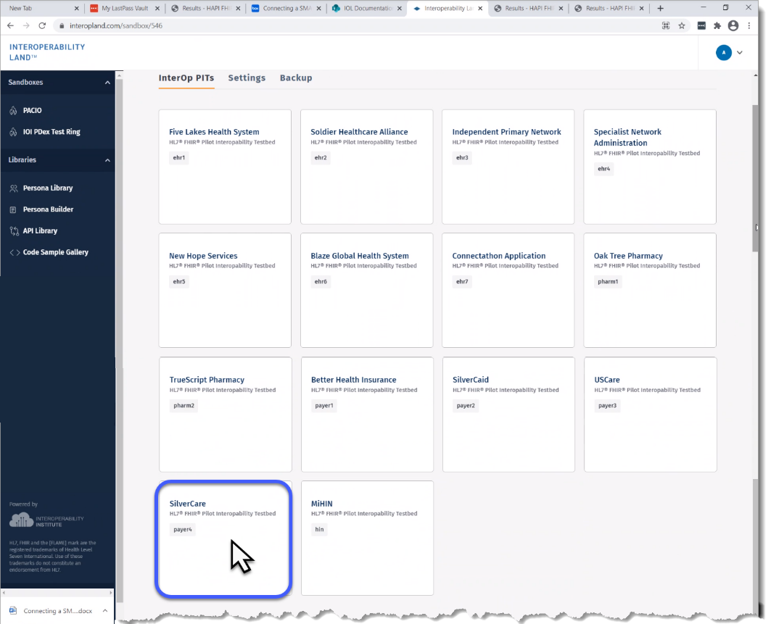

1. For this query you will use the Patient resource. Use the Search Parameters arrows to select **identifier- A Patient Identifier**. Type the patient’s **SSN** (000003215) in the **Code** corresponding box to find her patient Resource in the SilverCare PIT, as pictured below.
2. Click **Search** ().

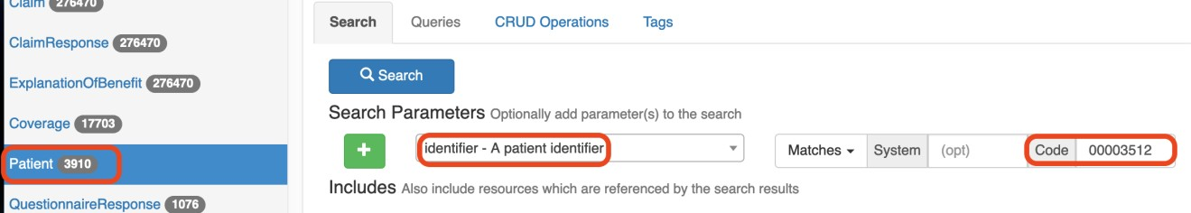

1. You can then make a note of Joyce’s id on this second payer PIT which is different from the one in the **Better Health Insurance**PIT.

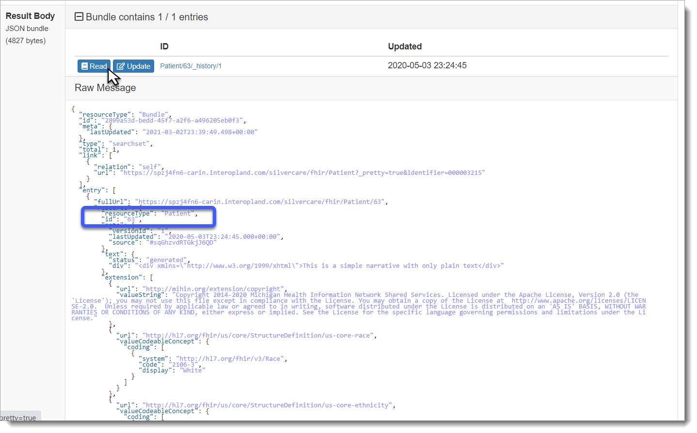***Note:*** *A PIT’s patient id is unique and recognized only by that PIT. A patient may appear in multiple PITs but will have a unique id in each one.*

***Tip****: To navigate the Explanation of Benefits Resource and review the patient’s coverage information, simply repeat the steps for Queries 2 and 3 from Scenario 1 in the SilverCare PIT with the appropriate patient id for SilverCare.*

# Scenario 3: Comparing Medication Prices

Using your **InterOp PIT Dashboard** choose your **Soldier Healthcare Alliance** PIT

## Problem Statement

Joyce wants to compare pricing information from several pharmacies to view where she can get the best price for her medication.

## Problem Solution

**Action:** Pull active meds for patients from EHR PIT and coverage from payer PIT, then cross reference with local pharmacies to identify the best price.

**Precondition:** Be able to utilize the queries listed below and access third-party prescription services.

**Success Criteria:** Successfully compare prices of an active medication for one of the patients in the PIT.

## Stakeholder Participation

Queries you will complete:

Finding the Patient’s id on an EHR PIT

1. Finding Medication Requests for a patient
2. Finding a Patient’s Coverage in the SilverCare PIT
3. Finding a Patient’s Prescriptions in Their EOB Records

#### Query 1 – Finding the Patient’s id on an EHR PIT (Soldier Healthcare Alliance)

It is possible to search for medication requests on an EHR PIT.

1. First, navigate to the EHR PIT you want to search via the Sandbox Dashboard.
2. Then, as above, use your Patient resource and set the **Search Parameters** to identifier, and enter the patient’s SSN in the **Code** space.
3. Click **Search** ().

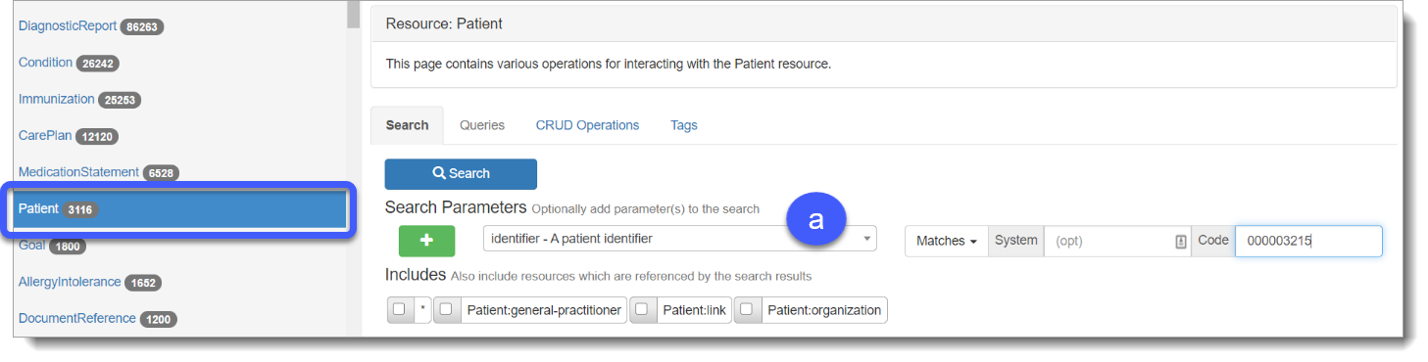

This search returns one result and provides us with the patient’s id on this PIT.

***Note:*** *This Identifier will be used in Query 2 to help locate medication requests.*

#### Query 2 – Finding Medication Requests for the Patient (Soldier Healthcare Alliance)

A medication request is initiated when a physician or provider orders a new medication.

1. To find the medications Joyce has been prescribed navigate your Resources menu and choose **MedicationRequest**Resource
2. Using the Search Parameters arrow choose the **patient – Returns prescriptions for a specific patient**option, type the patient Resource **id** acquired for Soldier Healthcare Alliance above in the corresponding box.
3. Click **Search** ().

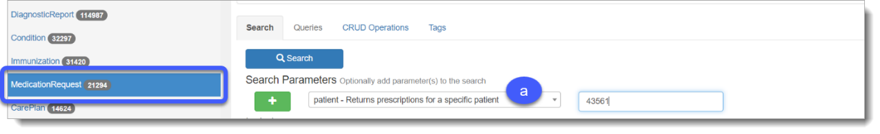

1. The query returns a list of MedicationRequest Resources.

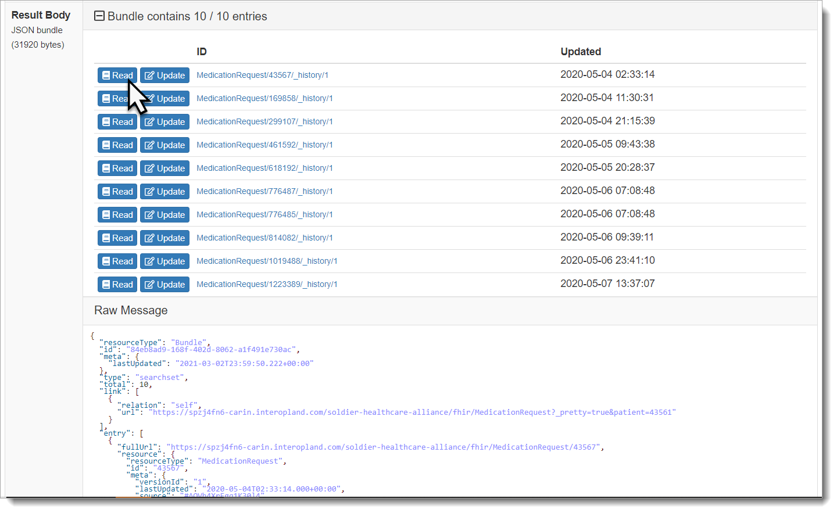

1. The Raw Message Resource contains information about what medications have been prescribed for Joyce. Now you can cross-reference these medications with a third-party service such as GoodRx to provide useful price comparisons.

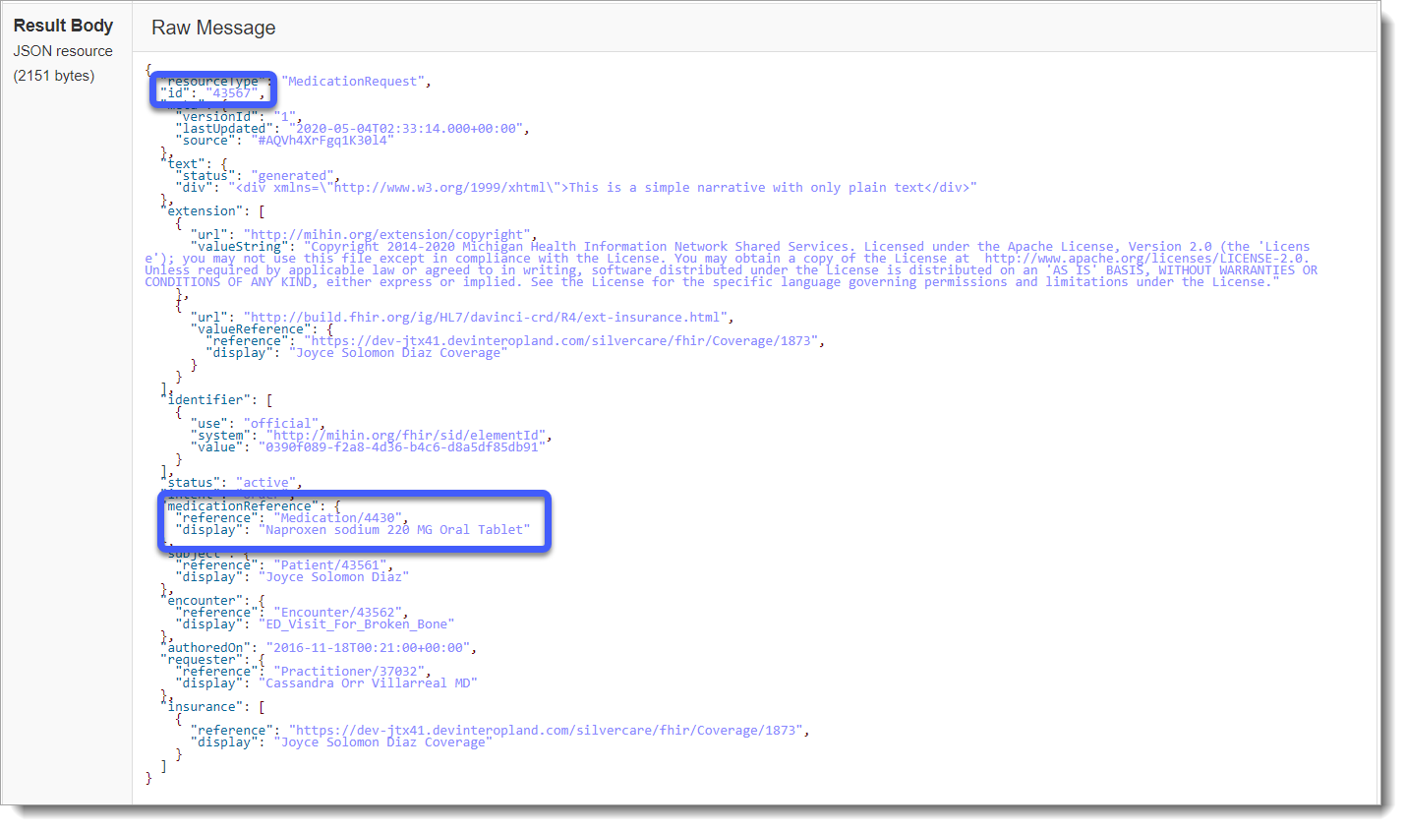

#### Query 3 -Finding a Patient’s Coverage in the SilverCare PIT

You have already located the patient Resource **id** (63) in the SilverCare PIT using the SSN as shown below.

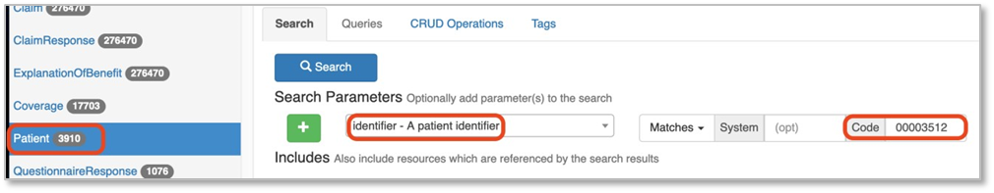

1. Search for your patient’s coverage information by choosing the **Coverage** Resource. Then using **Search Parameters** arrow choose the **patient – Retrieve coverages for a Patient** option, and the typing the **patient id** number in the corresponding box as seen below.

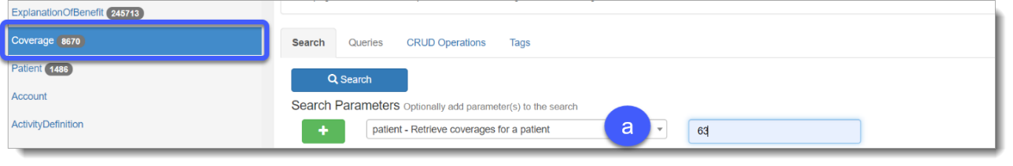

1. To view the patient coverage information, Add () a **Search Parameter**, choose **id – The ID of the resource**, verify **Matches** is active, and then using the corresponding box type the **coverage id** you located in the MedicationRequest Resource from the last query.
2. Click **Search** ().

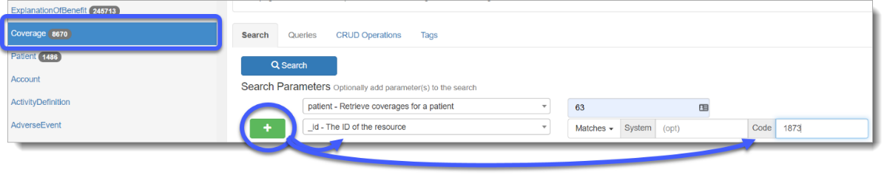

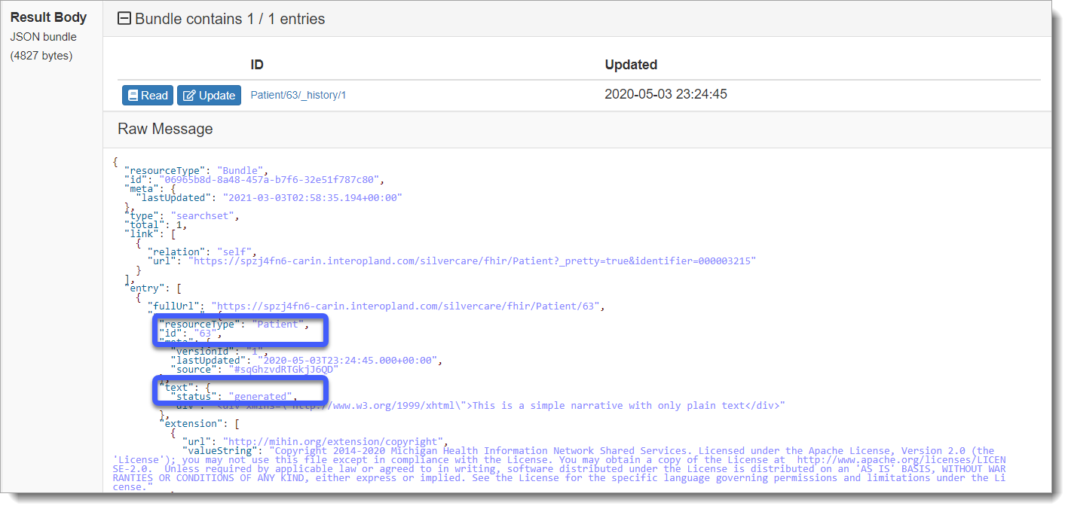

#### Query 4- Finding a Patient’s Prescriptions in Their EOB Records Using the Coverage id

By using the Coverage id (1873) from the previous query of the MedicationRequest Resource, it is possible to search the patient’s EOB records for prescription cost.

1. Click **ExplanationOfBenefit** on the Resources navigation menu.
2. Using your search **Search Parameters** arrow choose **patient – The reference to the patient**option and enter the **patient id** in the corresponding box
3. Click Add () to display an additional search option.
4. Using the Search Parameters arrow choose **coverage**- **The plan under which the claim was adjudicated**, and then type the **coverage id** in the corresponding box.
5. Click **Search** ().

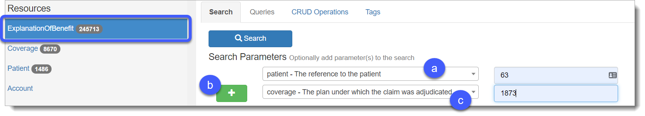

1. The query will return all EOBs for the patient related to that coverage period.

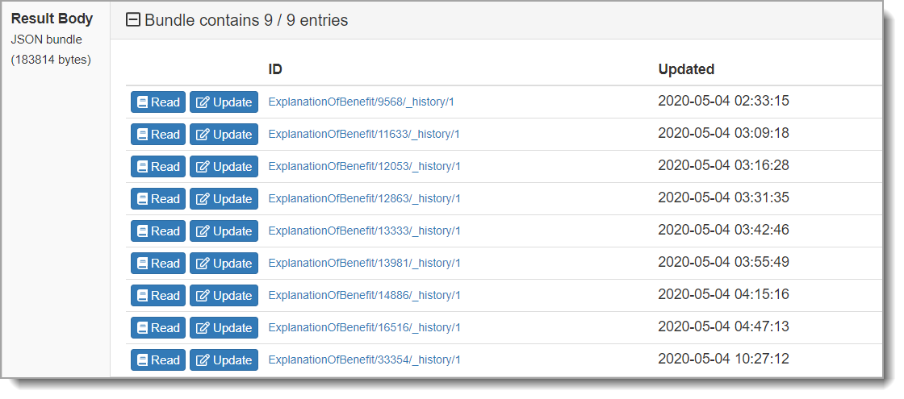

1. 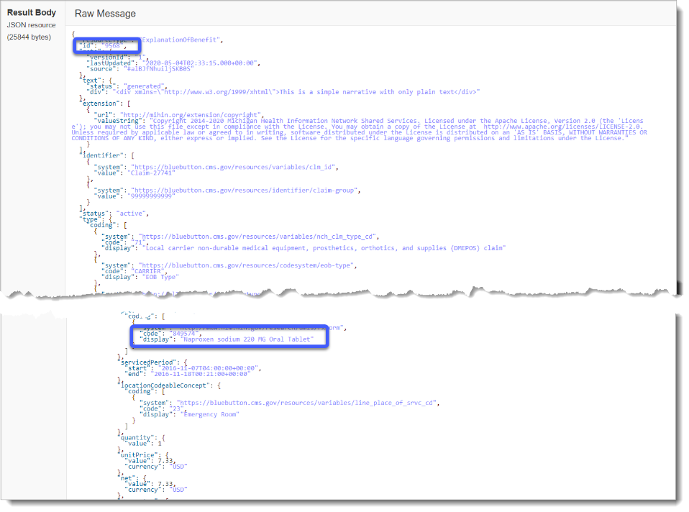Review your EOBs to locate the Resource with the Naproxen pricing information related to the Naproxen prescription from the MedicationRequest Resource query.

***Note:*** *Identifying prescription-based EOBs can be done by searching for* ***rxnorm*** *in the coding section of the record.*

# Appendix A: CARIN Blue Button Authentication Process

The information below will show you how to complete the following tasks for CARIN Blue Button Authentication.

1. Connecting a SMART on FHIR App
2. Creating a SMART Auth user
3. Connecting from the SMART on FHIR Application

The CARIN Blue Button architecture diagram shown below, demonstrates how the data flows from the request authorization for the Beneficiary data to the Payer and then redirects the user to the Auth UI. The user is then redirected to the InterOpathon App for both acquiring the token endpoint and using the token in FHIR to call the access Resources.



## Connecting a SMART on FHIR App

1. Using the **InterOp PITs** dashboard, choose the PIT you need to connect to the SMART on FHIR application. For this use case, selection should be a payer PIT.

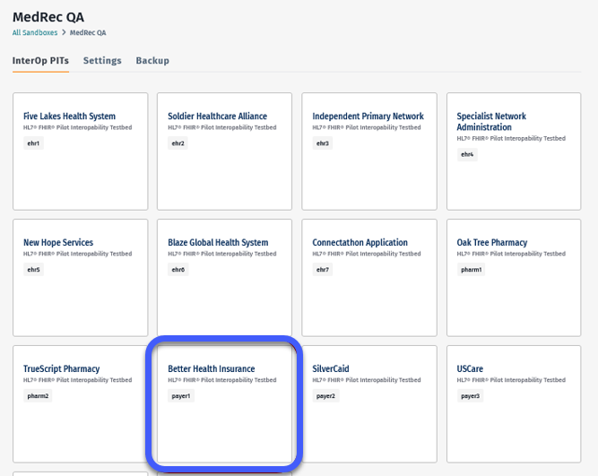

1. 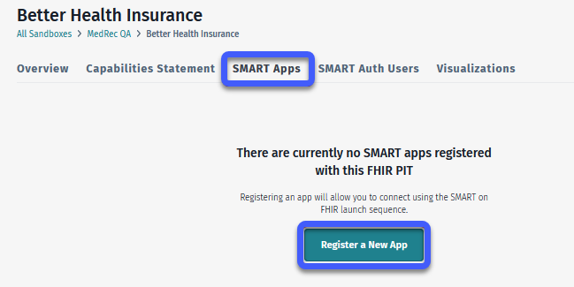Click the **SMART** **Apps** tab within the PIT, and then click **Register a New App**.
2. Enter your information in the **Register Smart App** form as follows.
3. **Name**. Name for identification of this SMART app.
4. 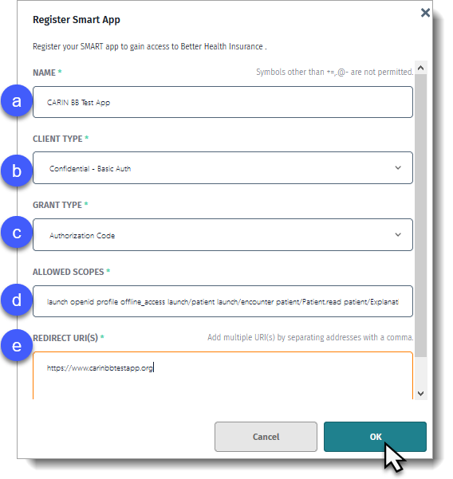**Client Type**. Configures how to make calls to the token endpoint. Client ID (username) and secret (password) generated by IOL will be passed to the endpoint via this selection. Default should be fine unless it is known that another form of authentication is used by the app.
5. **Grant Type**. Allows the application to request and receive the authorization token. Default option is Authorization Code.
6. **Allowed Scopes**. CARIN Blue Button FHIR Smart authorization scope of resources being requested for access.
7. **Redirect URI.** Redirect URI of the application being connected.
8. Click **OK** to display the Application Details page, and then click **Refresh** to populate your **Client Secret** anddisplay the following information.
9. <AuthServer URI from IOL> A place holder for the **Auth Server URI**.
10. <client_id> A place holder for the **Client** **ID.**
11. <redirect_uri> A place holder is for the **Redirect URI**s.
12. <scope_list> A place holder for the **Allowed Scopes** information.
13. <random> The **Nonce** is any randomly generated alpha-numeric sequence of 15 characters.

1. Using your Copy tool on the Auth Server URL section, click Copy, and then paste the login URL into NotePad® to edit. The highlighted sections in the string below are the placeholders that you will replace with the corresponding information on the Application Details page.

|  |
| --- |
| <AuthServer URI from IOL>/oauth2/login?login_type=patient&client_id=<client_id>&redirect_uri=<redirect_uri>&scope=<scope_list>&response_type=code&response_mode=fragments&nonce=<random> |

## Creating a SMART Auth User

This SMART Auth user is an example patient used to test whether the application connection process was successful.

1. 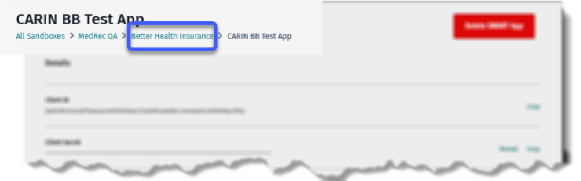Navigate to your PIT via the **breadcrumb** on the Application Details page.
2. 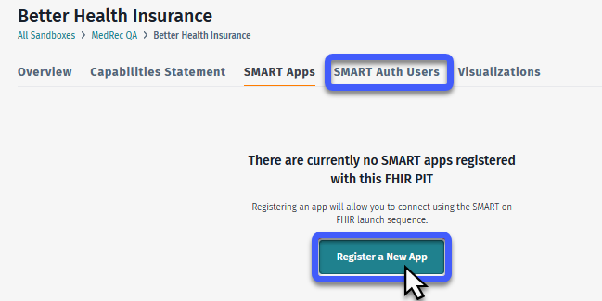Choose your **SMART** **Auth Users** tab and then click **Register a New App**.
3. Graphical user interface, application

   Description automatically generatedType your **Username**.
4. Create a **Password**.
5. Using the **User** **Type** arrow choose your User Type e.g., for CARIN Blue Button the user type should be **Patient**.
6. Using the **Patient** dynamic list box start typing your patient name and names will populate. When your **Patient** name displays click to choose.

***Tip****: The* ***Patient*** *arrow can be used to scroll to and choose a patient.*

## Connecting from the SMART on FIHR Application

There are two steps you need to complete for your Authorization Code and Token. The steps below will guide you through finding this information.

* Acquiring an Authorization Code using [oauthdebugger.com](https://oauthdebugger.com/)
* Obtaining a Token with an Authorization Code using Postman.

***Tip:*** *It is helpful to open both OAuth 2.0 <debugger> and the Better Health Insurance PIT in Interoperability Land. Then with both tools open, you can copy information from IO Land into the corresponding fields in OAuth debugger.*

### Acquiring the Authorization Code

For this process, you will need to copy information from IO Land and paste into corresponding fields in OAuth debugger.

* Navigate to and open [oauthdebugger.com](https://oauthdebugger.com/).
* Navigate to IO Land and use your sandbox Dashboard to open the **Better Health Insurance PIT**.

### Connecting Your PIT to OAuth debugger

1. Open your IO Land PIT and choose the **Capabilities Statement** tab to display your **Result Body JSON Resource**.
2. Copy the **valueUri** and paste into the OAuth debugger **Authorize URI** box.
3. Return to IO Land, open your registered SMART App **Details** tab, and then copy and paste as follows.
4. Copy **Client ID** from the SMART App and paste into **Client ID** in OAuth debugger.
5. **Graphical user interface, application

   Description automatically generated**Copy **Allowed Scopes** from the SMART App and paste into **Scopes** in OAuth debugger.
6. Update OAuth debugger as follows.
7. **State**. Type in a random string of characters.
8. **Response type**. Choose **code**.
9. **Response mode**. Choose **query**.
10. Click **Send Request**.

### Logging in as a SMART Auth User

After the application connects, you are redirected to the Logon page.

1. Graphical user interface

   Description automatically generatedUse your **Username** arrow to list available Smart Auth Users based on the auth type e.g., Patient or Practitioner.
2. Type the **Password**.
3. Click **Login**.
4. Click **I Approve** to grant permission to share Personal Health Information.
5. Leaving Patient and Encounter blank, click **Continue**.

### Obtaining the Access Token with Authorization Code Using Postman

1. In Interoperability Land, navigate to your SMART App **Details**.
2. Scroll to **Client ID** and click **Copy** to copy your username credentials.
3. Navigate to Postman and verify or choose the **Post** option.
4. Using your **Authorization** tab verify or choose **Basic Auth** as your authorization **Type**.
5. Paste your **Client ID** in the **Username** box.
6. Return to your SMART App **Details**.
7. Scroll to **Client Secret** and click **Copy** to copy your password credentials.
8. Return to Postman and paste your **Client Secret** in the **Password** box.

1. Next, using OAuth debugger **Success!** response and the **Body** tab in Postman complete the following.
   1. Verify or paste your **grant_type** e.g., authorization_code, in the corresponding VALUE box.
   2. Copy the **Authorization code** string and then paste into the corresponding VALUE box.
   3. Verify or paste your **redirect_url** e.g., <http://oauthdebugger.com/debug>, in the corresponding VALUE box.
2. **Graphical user interface, application

   Description automatically generated**Click **Send.**

1. **Graphical user interface, text, application, Word, timeline

   Description automatically generated**The response from the PIT will display your **access_token.**

# Appendix B: Bulk Querying Patient Data

Use bulk query to efficiently query large data sets and reduce the number of API requests. In this example, the Postman application is used to query the data.

1. Navigate to the **Auth** tab in Postman and use the **Type** arrow to choose **Basic** **Auth**.
2. Then type the **Username** and **Password** created when you created your SMART Auth User above.

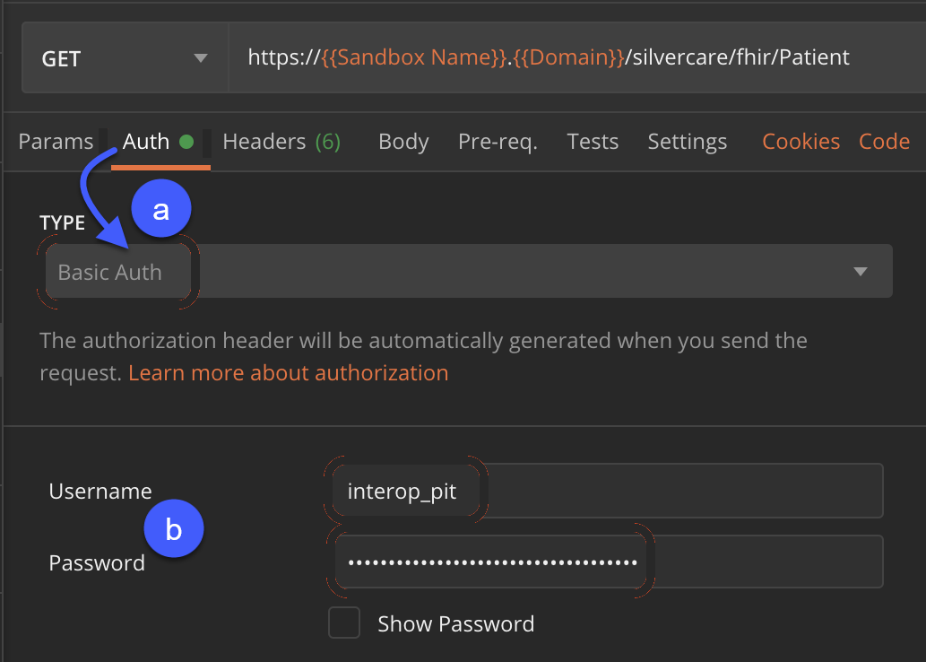

The results will include all Medicare patients. The same authentication can be used for ExplanationOfBenefits and Coverage records, and you will see unfiltered records for those Resources.

# Appendix C: Sample Users

|  |  |  |  |  |
| --- | --- | --- | --- | --- |
| **ID** | **SSN** | **Name** | **Username** | **Password** |
| 1 | 000003009 | Georgia Burgess | gburgess | !Iolconnect01 |
| 15 | 000003056 | Tamara Murillo | tmurillo | !Iolconnect02 |
| 25 | 000003087 | Dwight Frey | dfrey | !Iolconnect03 |
| 27 | 000003097 | Jennie Moon | jmoon | !Iolconnect04 |
| 29 | 000003111 | Nicholas Butler | nbutler | !Iolconnect05 |
| 31 | 000003112 | Alicia Atkins | aatkins | !Iolconnect06 |
| 33 | 000003123 | Franklin Marks | fmarks | !Iolconnect07 |
| 51 | 000003188 | Perry Cortez | pcortez | !Iolconnect08 |
| 53 | 000003189 | Jeffrey Gregory | jgregory | !Iolconnect09 |
| 55 | 000003193 | Fernando Grant | fgrant | !Iolconnect10 |
| 71 | 000003227 | Leah Carson | lcarson | !Iolconnect11 |
| 73 | 000003262 | Keith Mooney | kmooney | !Iolconnect12 |
| 75 | 000003265 | Benjamin Dixon | bdixon | !Iolconnect13 |
| 79 | 000003303 | Mabel Avery | mavery | !Iolconnect14 |
| 99 | 000003357 | Dustin Neal | dneal | !Iolconnect15 |

# Appendix D: Judging Criteria

Judging criteria vary according to event. Refer to the judging criteria distributed for your event.